TA Recruitment System User Manual
1. Overview
The TA Recruitment System is a web-based application for managing teaching assistant recruitment. It supports three user roles:
- **TA**: browse available positions, apply for positions, upload CVs, and view application results.
- **Teacher / MO**: publish TA positions, manage vacancies, pause or resume applications, and review applications.
- **Admin**: manage user accounts, roles, account status, and teacher accounts.
The system interface is in English and is designed for local deployment on a Java Servlet container such as Apache Tomcat.

## 2. Login
Open the application in a browser. The login page allows users to enter their account ID or student ID, password, and selected role.
Users must select the correct role for their account:
- TA accounts enter the TA workspace.
- Teacher accounts enter the teacher dashboard.
- Admin accounts enter the admin console.
If the role does not match the account, or if the account is disabled, login will be rejected.
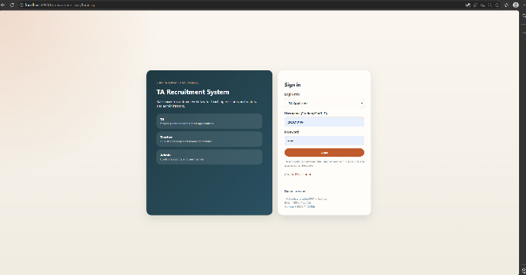

## 3. TA User Guide
### 3.1 Register a TA Account
TA users can create their own account from the registration page.
Required fields include:
- Student ID
- BUPT email address
- Name
- Password
- Confirm password

Registration rules:
- Email must use `@bupt.edu.cn` or `@mail.bupt.edu.cn`.
- Student ID must be unique.
- Email must be unique.
- Password must be at least 8 characters and include uppercase, lowercase and a number.

After successful registration, the user is redirected to the login page.
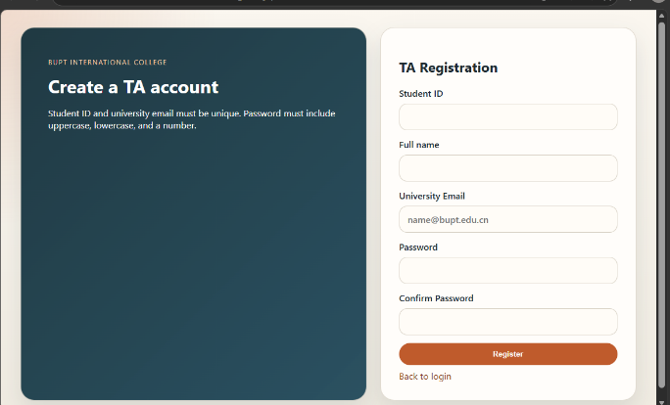

### 3.2 Browse TA Positions
After logging in as a TA, the user enters the available positions page.

The position list shows:
- Position title
- Module code
- Module name
- Workload
- Deadline
- Remaining slots
- Position status
- Apply button

The position status may be:
- **Available**: the position is open for applications.
- **No Vacancy**: all available slots have been filled.
- **Closed**: the deadline has passed or the position is no longer open.

Cancelled positions are hidden from the main TA position list.
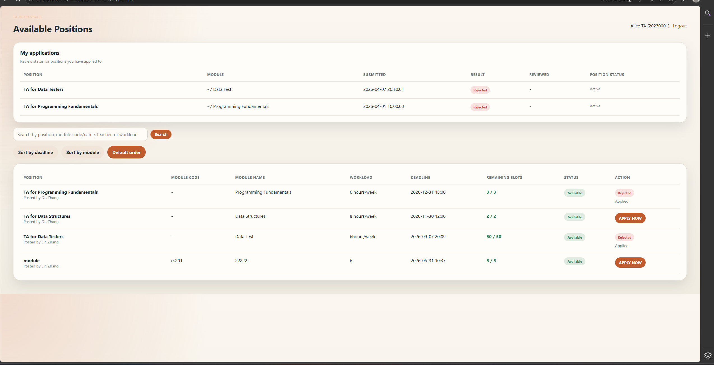
### 3.3 Search and Sort Positions

TAs can search positions by:
- Position title
- Module code
- Module name
- Teacher name
- Workload

TAs can also sort positions by:
- Deadline
- Module

If no positions match the search, the system displays an empty-state message.
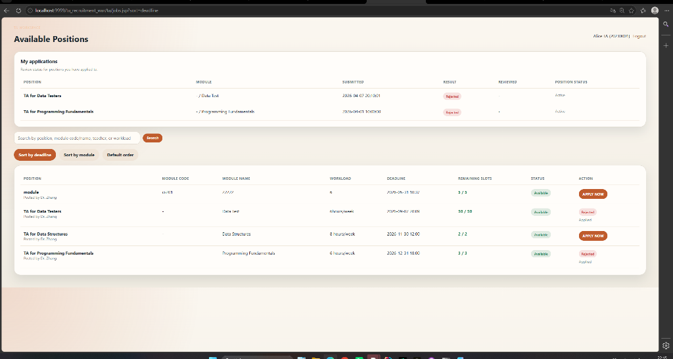
### 3.4 Submit an Application
When a position is available, the TA can click **APPLY NOW** to open the application form.
The application form requires:
- Skills
- Weekly availability
- Relevant experience
- Resume / CV upload

Resume upload rules:
- File type must be PDF or DOCX.
- File size must be 5 MB or below.
- The uploaded file is automatically renamed using the format `StudentID_timestamp.ext`.

The system prevents duplicate applications for the same TA and position.
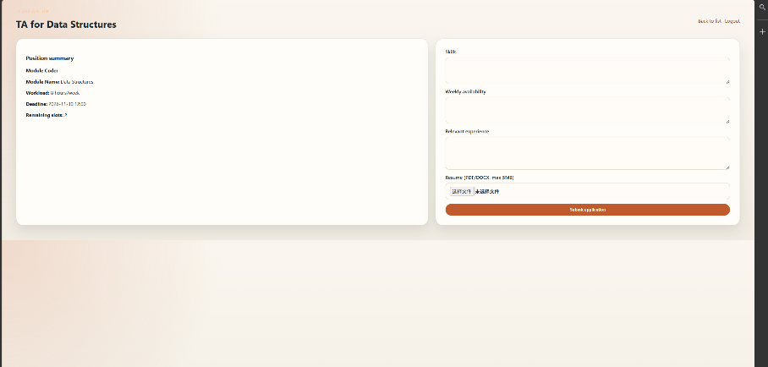
### 3.5 View Application Results
After submitting applications, the TA can view the **My applications** section on the TA workspace.
This section shows:
- Position
- Module
- Submitted time
- Result
- Reviewed time
- Position status

Application result values include:
- **PENDING**: the teacher has not made a decision yet.
- **ACCEPTED**: the application has been accepted.
- **REJECTED**: the application has been rejected.

If a position has been cancelled after application, the application history indicates that the position was cancelled.
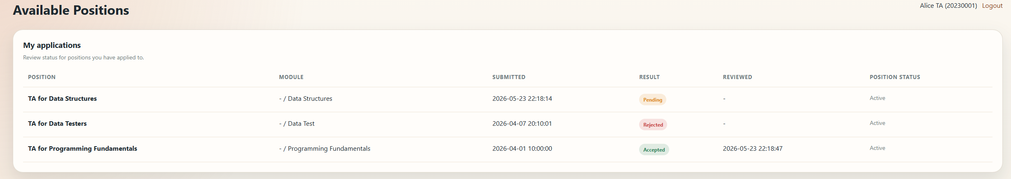

## 4. Teacher / MO User Guide
### 4.1 Teacher Dashboard
After logging in as a Teacher / MO, the user enters the teacher dashboard.
The dashboard shows:
- Total applications
- Pending review count
- Number of owned positions
- Position publishing form
- Teacher-owned position list
- Applications for the teacher's positions

Teachers can only view and manage their own positions and applications.
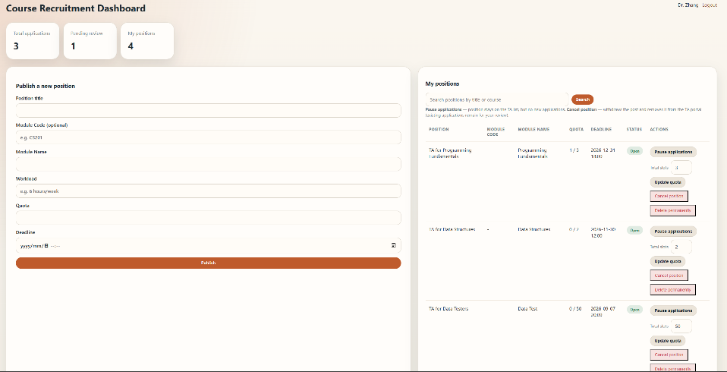
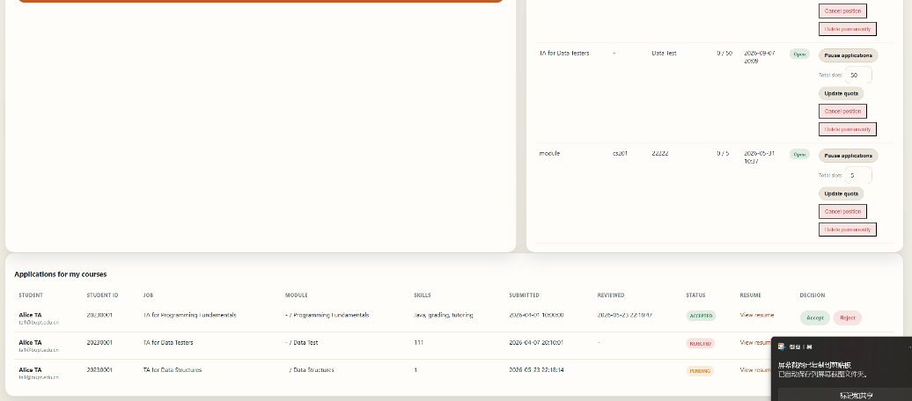
### 4.2 Publish a New Position
Teachers can publish a new TA position by filling in:
- Position title
- Module code
- Module name
- Workload
- Quota
- Deadline

The system validates that the deadline and quota are valid before publishing the position.
After publishing, the position becomes visible to TAs if it is not cancelled, not paused, before the deadline and has remaining slots.

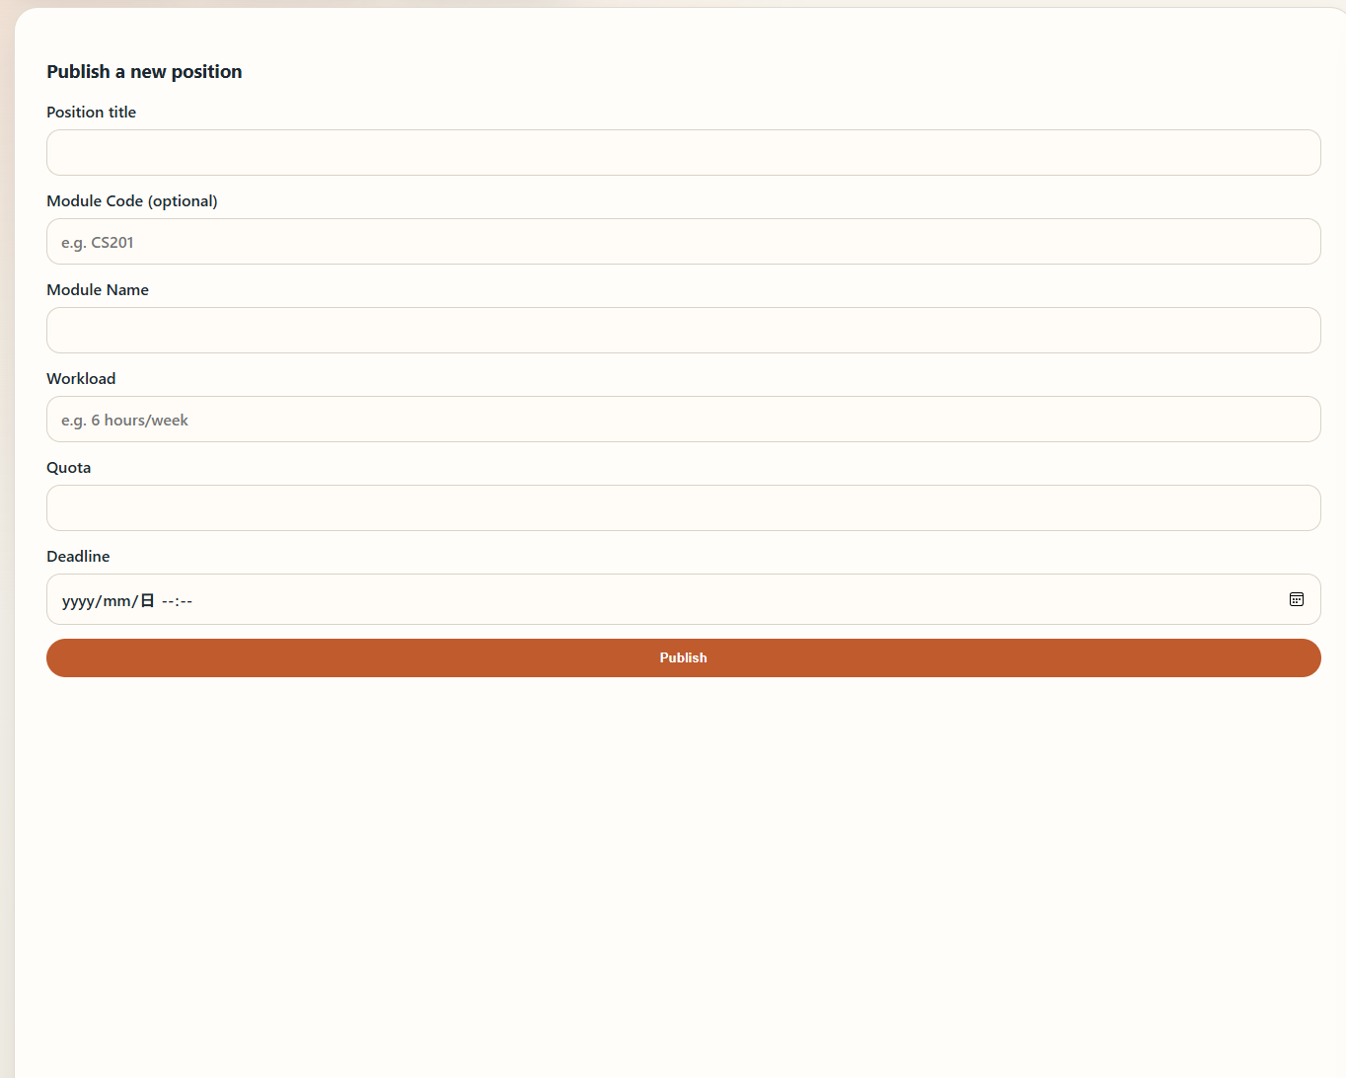
### 4.3 Manage Published Positions
Teachers can manage their own positions from the position table.
Available actions include:
- **Pause listing**: stop accepting new TA applications while keeping the position visible.
- **Resume listing**: allow new applications again if the deadline and quota still allow it.
- **Update quota**: change the total number of slots. The quota cannot be lower than the number already filled.
- **Cancel position**: withdraw the position and remove it from the TA portal.
- **Delete position**: delete the position and remove its related applications.

The teacher dashboard displays whether a position is open, paused, full, closed or cancelled.
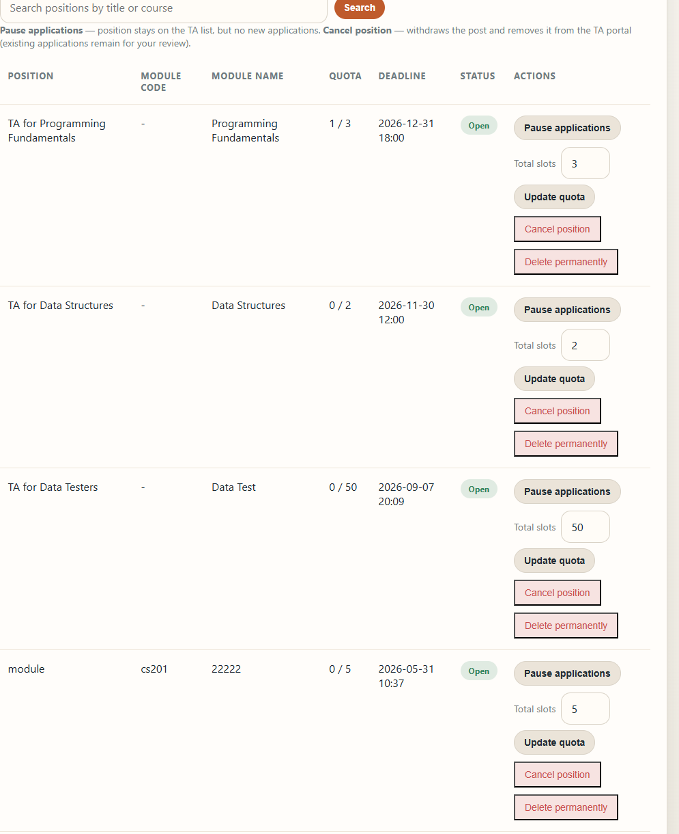

### 4.4 Review Application
Teachers can review applications submitted to their own positions.
For each application, the teacher can view:
- Student information
- Job title
- Skills
- Submitted time
- Application status
- Resume link

Teachers can choose:
- **Accept**
- **Reject**

When an application is accepted:
- The application status becomes `ACCEPTED`.
- The job's filled slot count increases.
- The TA can see the accepted result in the TA workspace.

When an accepted application is later rejected:
- The status becomes `REJECTED`.
- The filled slot count is reduced.

The system prevents accepting applications when the position is cancelled, paused or has no remaining slots.
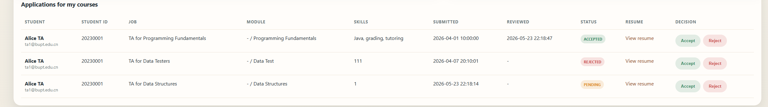

## 5. Admin User Guide
### 5.1 Admin Dashboard
After logging in as Admin, the user enters the account control center.
The admin dashboard supports:
- Creating teacher accounts
- Searching users
- Filtering users by role
- Editing roles
- Enabling or disabling accounts
- Resetting passwords
- Deleting accounts
- Batch enabling or disabling selected accounts
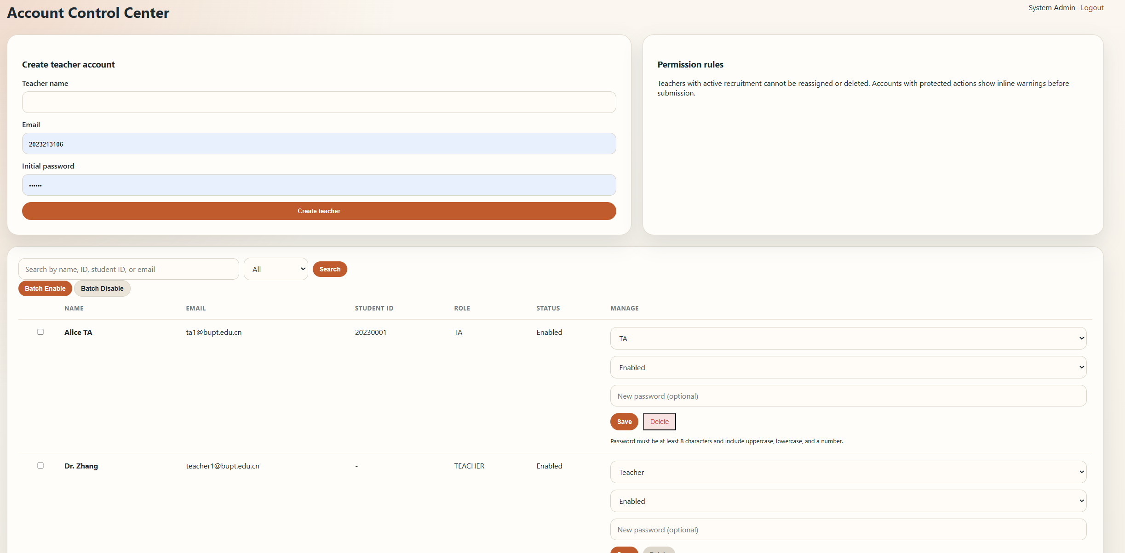
### 5.2 Create a Teacher Account
Admins can create a teacher account by entering:
- Teacher name
- Email
- Initial password

The initial password must satisfy the same strong password rule:
- At least 8 characters
- Contains uppercase letter
- Contains lowercase letter
- Contains number
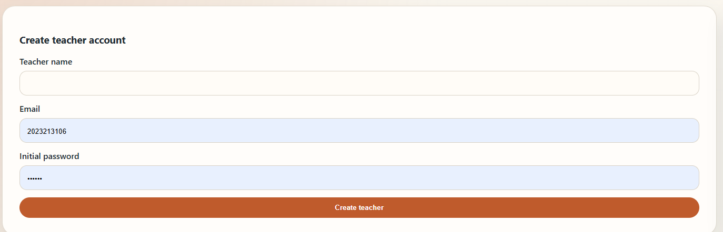
### 5.3 Search and Filter Users
Admins can search users by:
- Name
- User ID
- Student ID
- Email

Admins can also filter users by role:
- All
- TA
- MO / Teacher
- Admin

If no user matches the search or role filter, the system displays an empty-state message.
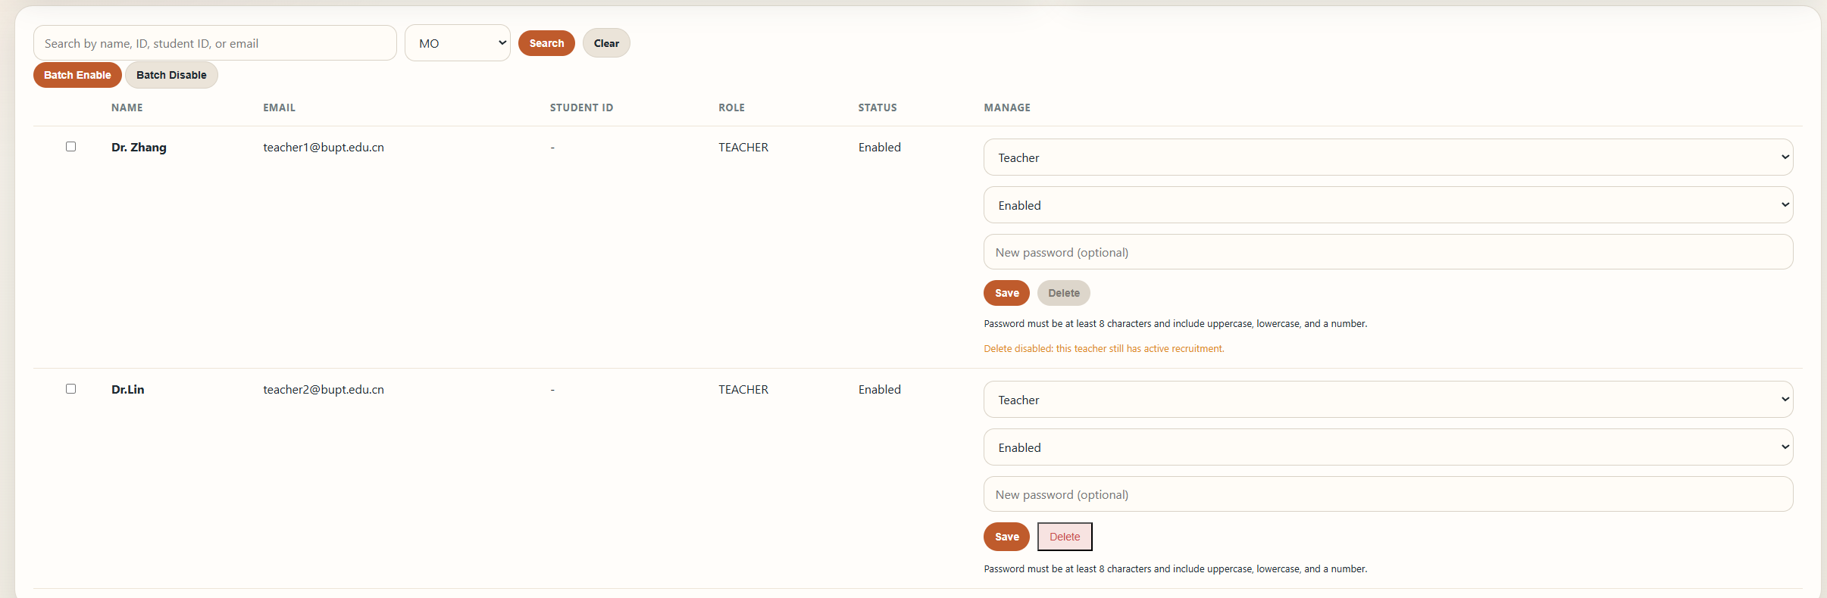
### 5.4 Manage User Accounts
For each user, admins can:
- Change role
- Enable or disable account
- Reset password
- Delete account

Safety rules:
- Admin cannot delete their own account.
- Admin cannot disable their own account.
- Admin cannot demote their own account from Admin.
- Teachers with active recruitment cannot be deleted, disabled or reassigned.
- Deleting a TA also removes the TA's related applications and recalculates filled slots.
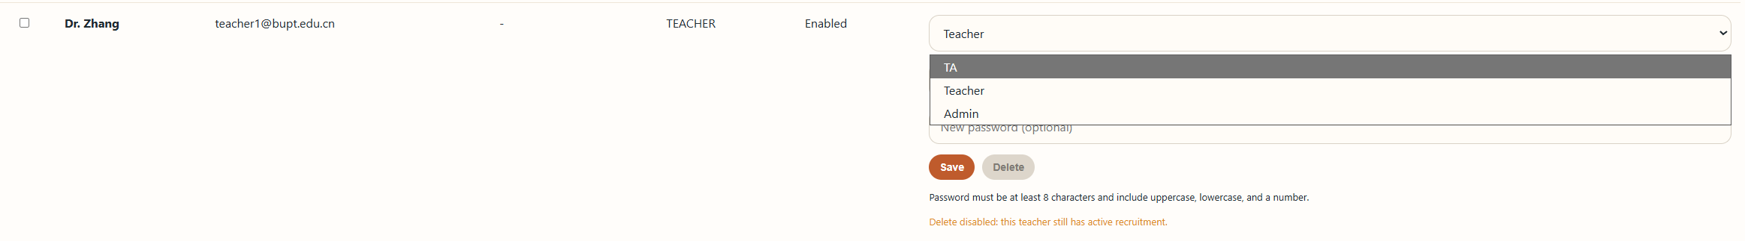
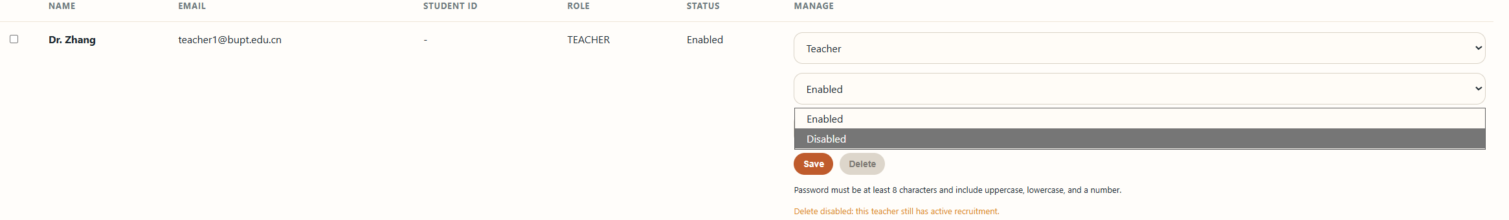
### 5.5 Batch Enable / Disable
Admins can select multiple users using checkboxes and apply batch actions:
- Batch Enable
- Batch Disable

The system prevents unsafe batch operations such as disabling the current admin account or disabling a teacher with active recruitment.
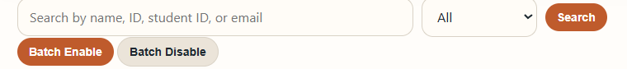
## 6. Common Error Messages
The system displays messages when an operation cannot be completed. Common examples include:
- Invalid credentials or disabled account.
- Selected role does not match this account.
- Email already exists.
- Student ID already exists.
- Password is too weak.
- Resume must be PDF or DOCX.
- Resume file is too large.
- This position is no longer available.
- You already applied for this position.
- No remaining slots.
- Unauthorized operation.
- Teacher has active recruitment.

## 7. Logout
All user roles can log out using the **Logout** link in the page header.
After logout, the current session is cleared and the user is redirected to the login page.

